Paris Session 46 - Presentations

The 2016 Paris Session has shown that new solutions for microgrids and bulk transmission will be needed. Most notably it clearly demonstrated that we are not alone and many countries around the world have embarked on a program of rapid installation of renewables.
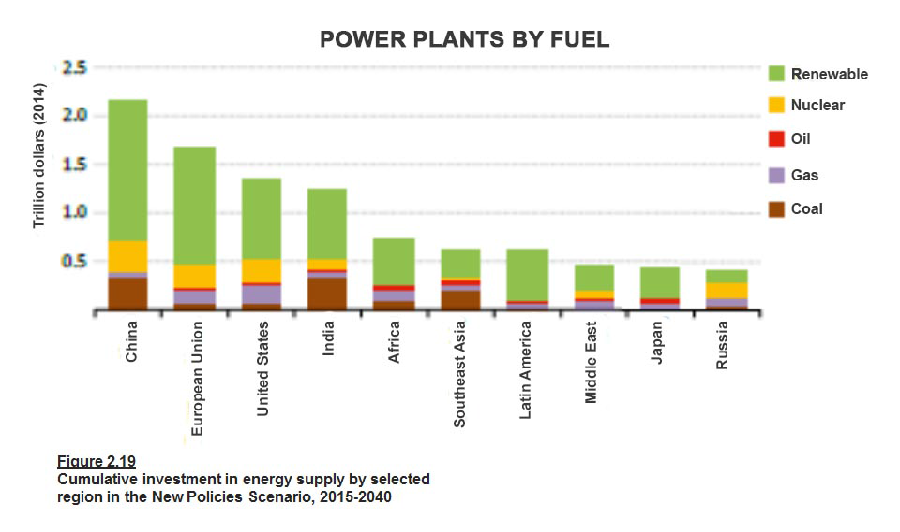
Source, IEA, WEO 2015

Microgrids

During the opening panel, there was a very interesting presentation on microgrids as contributors to energy security and system stability by Geza Joos from McGill University. Much of the recent discussions in Australia following the South Australian blackout have been on the need to improve the interconnected transmission system. This presentation suggests that microgrids should also be considered as potential solutions.

Microgrids can operate in a controlled way either connected to the main power network or islanded. Examples from around the world included university campuses, hospitals and isolated power systems such as in remote parts of West Australia. It is also interesting to note that a focus has been placed on this in the US following Superstorm Sandy that caused major blackouts across New York. The solutions can include renewable generators, backup diesel generators, battery banks, and embedded load control.
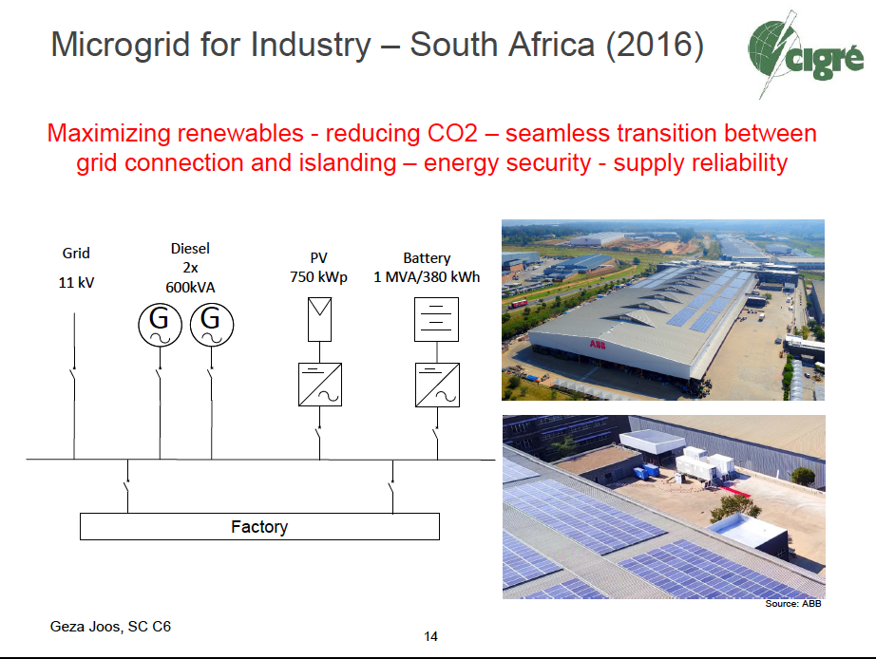

These solutions can enable the reconfiguration of distribution systems, integrate distributed energy resources, enable market participation of the distributed energy resources and allow customer and end use empowerment.

Depending on the economics of the particular area, a business case can be made to use microgrids to enhance grid resilience and stability, enhance energy security using local energy resources, match power quality to the end-user requirements, provide voltage and frequency ancillary services to the grid and lower the carbon footprint.
Management of the Solar Eclipse that affected Europe on March 20 2015

At the Workshop on Large Disturbances, Christoph Schneiders from Amprion in Germany gave a presentation on a new system operational challenge. He described the extensive preparations that were necessary to prepare for the solar eclipse in 2015. The installed PV capacity in Continental Europe is approximately 89GW and it was determined that the eclipse could potentially cause a reduction in output of more than 34GW. In addition it was expected that during the eclipse, the rate of decline in output and the subsequent rate of increase in output would be 2 to 4 times normal PV ramping rates. This placed an increased demand on flexible power plants.

In Germany, approximately double the amounts of fast start generation reserves were allocated and special operating procedures were put in place. There was also an extensive campaign to raise awareness and allocate responsibilities to all distribution and transmission system operators. Planned network outages were kept to a minimum, staffing in control rooms was increased and extra training was undertaken.

In the end things were not as bad as expected due to more than expected fog that limited the PV output. Nevertheless, the output still declined 17GW and then increased 26GW. Due to the extensive preparation for the event, the incident was managed smoothly. There are lessons here for Australia as the amount of installed PV continues to rapidly increase.
Generation (GW)

PV Generation in Continental Europe, March 20, 2015

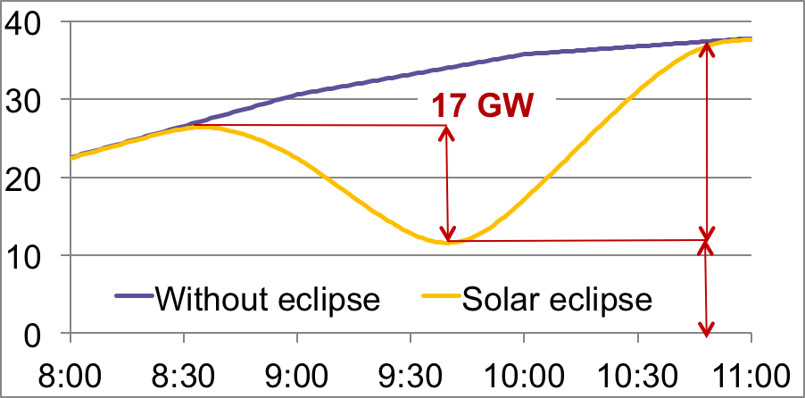

Key conclusions were:

- Detailed forward planning is essential
- Increased fast start generation is needed to be on short term standby
- Special emergency procedures must be in place
- Good forecast quality is needed
- Controllability and observability of PV generation is desirable
- Strong cooperation and transparency amongst all distribution and transmission operators is highly desirable with a clear understanding of remedial actions and ways to implement them
- The challenge during this type of event will continue to increase as the level of PV installation continues to increase.

